“WHAT IN THE WORLD
WERE YOU THINKING?”
Thinking Can Change Your Life
So, what are you thinking?

Your fear is because you have filled your mind with the catastrophic (the worst that could happen) or the anastrophic (the best that could happen).

The primary cause of fear is thinking about and trying to live in the future.

Or, as Seneca says, “Instead of adapting ourselves to prevent circumstances, we send our thoughts too far ahead.” It is a projection to the future about something we do not control that causes a dangerous amount of worry.

Object

The actual damage from our fear pales compared to the damage we do to ourselves as we blindly try to prevent what we fear.

Epictetus explains: “When I see a man in a state of anxiety (fear), I say, ‘What can this man want?’ If he did not want something which is not in his power, how could he still be anxious? For this reason, one who sings to the lyre is not anxious when performing by himself. But, when he enters the theatre, even if he has a very good voice and plays well, he is afraid, for he not only wants to perform well but also to win a great name, and that is beyond his own control.” And that is how you create fear.
Fear is the excuse we use for not doing something. Could you get up in front of 200 people and sing? Okay, most of you said you couldn’t do that because you’d be too afraid. Then, let me rephrase it. For $9,000,000, tax-free, could you get up and sing in front of 200 people? It doesn’t matter how good you are; all you must do is get up and sing. Could you do that? Suddenly, I see a lot more hands going up.
When you want something that is not under your control, that is when the problem begins. You fear because you want what you think is outside your power. Or, it is just not important enough for you to do it.
You are attracted to a person you see as beautiful, but you won’t approach them because of your “fear” of rejection. Would you be willing to risk rejection for $9,000,000?
You are attracted to the security of a government job with a regular salary because you fear the risk of being on your own. You feel that you are not capable and that you will make mistakes, and you will. So you will not take the “risk” of starting your own business. Your security is not in your power to control. However, you will succeed if you make your mistakes into learning opportunities. The most successful people are the ones who make the most mistakes and learn from them.
People do what they are afraid of all the time. Soldiers charge up the mountain under withering fire, knowing it will kill some of them. They are so scared that some of them will wet their pants. But it does not stop them. A parent will dash into a burning building to rescue their child.
Fear has never stopped anyone
from doing what they want to do!

Birds fly, fish swim, and people feel. You are not condemned to be a reactor. You are free to choose both your feelings and your behaviors. The way you feel is determined by what you are thinking. Your behavior is based on the awareness of what you feel. You can only make decisions based on what you are aware of. What beliefs do you hold that are creating your feelings of not being capable?
Walking in the woods, you suddenly come upon a bear. Your fear is based on what you have been told about bears. Then, you meet the bear’s owner and discover it is an old, toothless pet bear. Your fear goes away as soon as you believe the bear is harmless.
Seeing A Bear >> Belief About Bears >> Feelings of Fear >> Run away
Seeing Bear As Safe >> change beliefs >> Feelings of Delight >> Interact

Or, to say it another way. The following graphic illustrates this concept: Something happens (events, people, words). You put a judgment on what has happened or was said. (Meaning, beliefs, expectations, and conclusions). Depending on which meanings you choose, you will feel the corresponding feelings. Change what something means to you, and you change your feelings. It is from your feelings that you choose your behaviors.
You feel the way you do right now because of the thoughts you are thinking at this moment. David Burns MD 1981
* * *
There is nothing either good or bad, but thinking makes it so. Shakespeare, Hamlet 1599 A.D.
It will do no good to look at the beliefs creating your messed-up life if you don’t believe you are responsible and you are choosing what you are thinking.
A feeling is a feeling, is a feeling. A feeling, by itself, is not good or bad. It is the behaviors that you choose that will determine whether your behavior is good or bad.
You are responsible both for your feelings and for your behaviors. The writer Hemingway puts it this way: “Everything is your fault. . . . . . . if you are lucky.” If something is your fault, then you can change it. The more things are your fault, the luckier you are. If you are sitting at a red light and somebody rear-ends you, it wasn’t your fault, and you were unlucky.
Fear is your fault. “If external things pain you, it is not they that disturb you, but your judgment of them. And, it is in your power to wipe out that judgment now.” Marcus Aurelius 121 A.D.
In industrial psychology, they say that for every mistake you make during your job interview, you will need ten positives to counteract the one negative.
I suspect that may be true for the negative experiences you base your negative self-talk on. One fearful event or failure need not scar you if you remember that you are the one choosing to think. “I am not capable.” “No one will accept me; I will be rejected.” “I will make a fool of myself, and no one will want to be around me.” Your thinking does not stop with just one thought. All your thinking is created by you and can be changed by you.
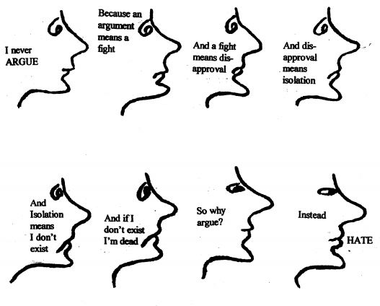
How to change your thinking:
There are three ways to change your thinking:
- First, you get through fear by doing what you are afraid to do. This would be a behavioral approach. I had a client who was a pilot of a B-29 during World War II. He told me that he was shot down three different times. He described his parachute training. “The first time I jumped out of a plane, I wet my pants.” The second time I jumped, I didn’t wet my pants! By the 20th jump, I had no fear, just excitement.”
- The next way is by changing what you think. You can use a logical, left-brain approach where you use “insight therapy” to understand that you are choosing to think and can think anything you want. This left-brain approach works best when the negative event is not associated with an emotional event from the past.
- Using right brain therapy. The right brain is not logical, is not sequential, cannot systematically figure out what has or is happening. Have you ever tried giving a rational, logical answer to someone who was struggling emotionally? To you the answer is simple, however your friend just cannot do what he needs to do to make his life simpler. This is one of the signs that the person has a right brain picture that keeps coming to consciousness and is interfering with being able to make a life-changing decision. Below are listed several right brain interventions that a therapist could use to get the client through his impasse.
- By using Role-Play. This is where you emotionally reenact the negative event. This time, you are guided to experience a positive outcome. This right-brain approach is often used to get rid of PTSD flashbacks. This is best done with a therapist. The therapist will use verbal and behavioral reenactment to help you re-live the trauma. In the reenactment, you win and become the victor rather than the victim.
- By using visualization or hypnosis. This approach can be used with major loss and grief issues. This also works well for saying “goodbye” to loved ones you feel incomplete with. This is sometimes used to achieve smoking cessation. This technique is best done with the therapist.
- Mutual storytelling is often used with children to empower them after a traumatic event. Parents and therapists can use this right-brain approach with small children, where they create the story together and help them discover positive outcomes.

You can create the changes you want once you accept responsibility for everything you think.
These therapeutic approaches, Cognitive, Behavioral and Affective can be used individually or by combining all three into a Cognitive-Affective-Behavioral Therapy, the CABT approach:
- Cognitive/Thinking.
- Behavioral.
- Affective/Feeling.

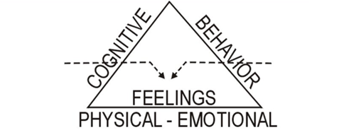
Stopping emotionally disabling fear or other emotional issues, can be achieved through cognitive (beliefs, thinking, judgments) OR through the person’s behavior (doing what they are afraid to do), or by working directly with their feelings. But unless there is a permanent change in the feelings, there will be no permanent change in the behavior.
Since each person’s issues are different, the therapist may try all three approaches before finding the one best suited for the client to achieve change.
You can contact Dr. Downing at:
Email: DocDowning103@gmail.com
Website: DocDPhD.com

